

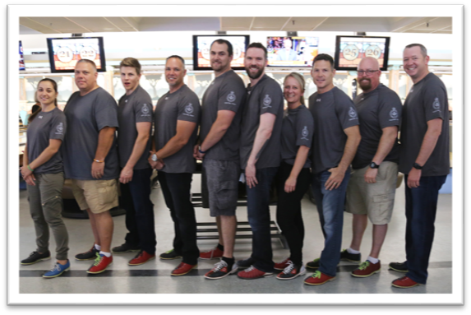

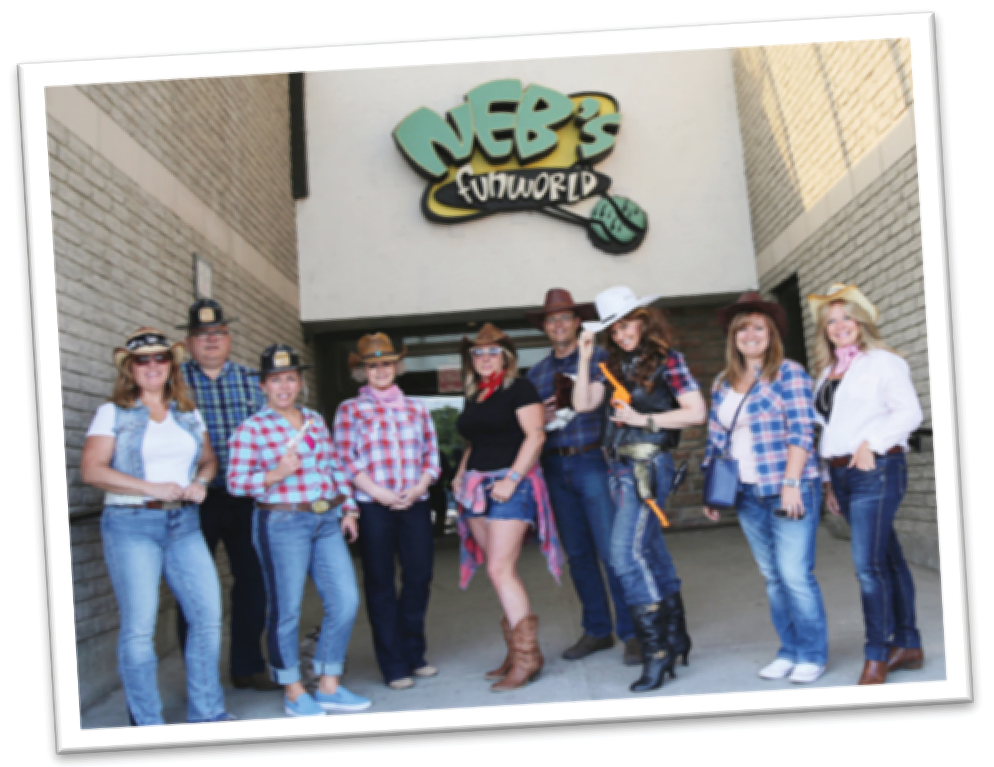
BOWLING NIGHT
WHEN: Thursday, June 6th, 2019 from 6:00 PM to 9:00 PM
WHERE: NEB’s Fun World, 1300 Wilson Road North, Oshawa
REGISTRATION FORM

 YES, I would like to register a team!

I am unable to attend, but I would like to support ProAction’s Durham Chapter by making a donation!

*To make a donation by credit card, please visit www.copsandkids.ca/donate

Registration Contact: ____________________________

Company (if applicable): _________________________

Address: ______________________________________

City: _________________ Postal Code: ____________

Phone:________________________________________

Email:________________________________________

Team Name: __________________________________

Team Members: 1____________________________
2____________________________
3____________________________
4____________________________
5____________________________
Registration is $500.00 per team (Minimum)
Teams are invited to solicit pledges to cover the fee!

Please send invoice

Enclosed, please find cheque payable to:
ProAction Cops & Kids
40 College Street, Suite 623
Toronto, ON M5G 2J3

Kindly mail completed form to address above or email jessica@copsandkids.ca by Friday May 24, 2019

PRIZES FOR BEST TEAM SPIRIT!
HINT: COSTUMES ARE ENCOURAGED

Bowling Team ($500 minimum) Includes:
- Bowling for 5 Players, Food & Soft Drinks

Bring the whole family for a fun night out!
Great for team building!

FOR MORE INFORMATION:
Please contact: Jessica Field
jessica@copsandkids.ca | 416-222-7011

