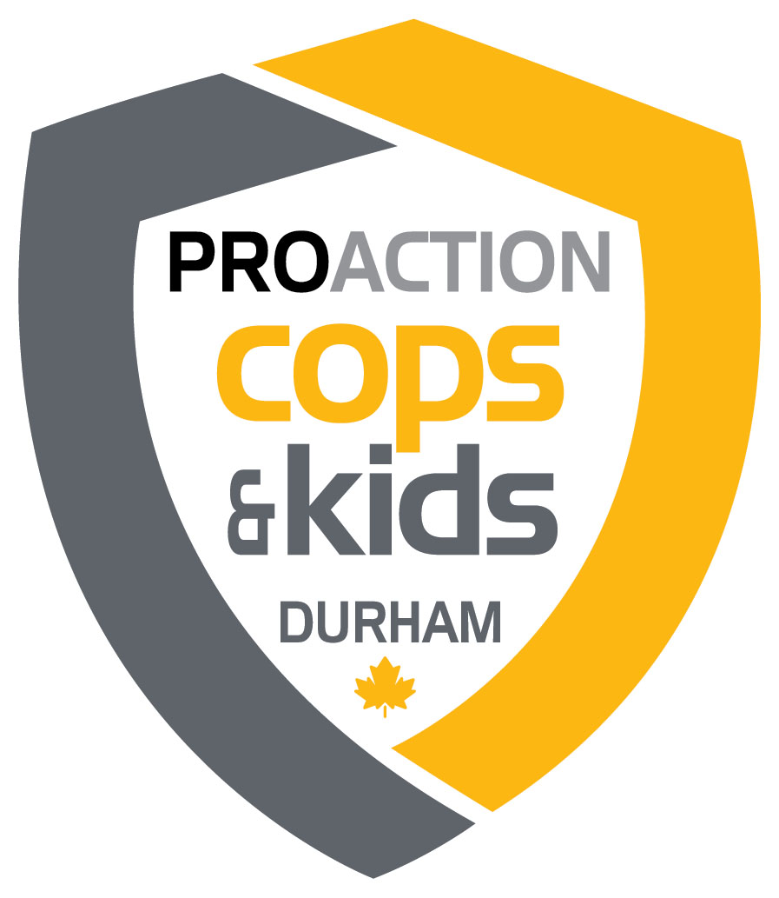

NOMINATION FOR THE PROACTION DAVE WILSON AWARD

Inspector Dave Wilson served as ProAction’s Police Liaison from 2007-2012. During this time, he was instrumental in promoting, creating, and developing meaningful police-run programs for youth at risk. This award is named in his honour.

To recognize the police officer who has shown the most remarkable level of commitment to police-youth in-person or virtual program(s) which took place in 2022 across Durham Region and was funded by ProAction.

Eligibility: 1). Time spent by the officer on creating and/or participating in
ProAction funded youth programs.
2). Exceptional care and effort exercised in planning and execution of
programs.
3). Impact of the officer on police-youth relationships.

Nomination: Police officers are asked to forward their recommendations to
nicole@copsandkids.ca no later than Friday January 13, 2023.
Recommendations for this award shall be reviewed by the Durham
Chapter Council in consultation with the Durham Police Liaison.

Presentation: This award shall be presented at the ProAction Cops and Kids
Annual General Meeting

Requirements: 1). Limit each answer to 250 words or less.
2). Complete the form to its entirety, making sure it meets criteria.
3). Nominee must be a police officer.
4). Please ensure the program either started, falls, or runs in the year
being considered.

Submitting Officer:
(Nominator)
Recipient Name & Rank:
(Recipient)
Division / Unit:

Name of ProAction funded program the officer created, developed, or runs:

Did the officer start the program(s)? If so, when? If not, how long has the officer been involved?
Describe the officer’s commitment of time over the life of the program, how did the officer go above and beyond the normal commitment to achieve success with their program? (s).
How many hours did the officer dedicate to the program?
Off Duty:
On Duty:

Describe the care and effort exercised by the officer in planning and execution of police-youth programs:
What impact has this officer had on police-youth relationships? Please provide a specific example of how a youth was impacted:
Has the officer enthused or attracted other police officers to participate in police-youth programs? How?
Additional Comments:

Please email this form along with any attachments you wish to include
by Friday January 13, 2023 to:

Nicole Benoit – Administrative & Program Coordinator
nicole@copsandkids.ca

Thank You!

