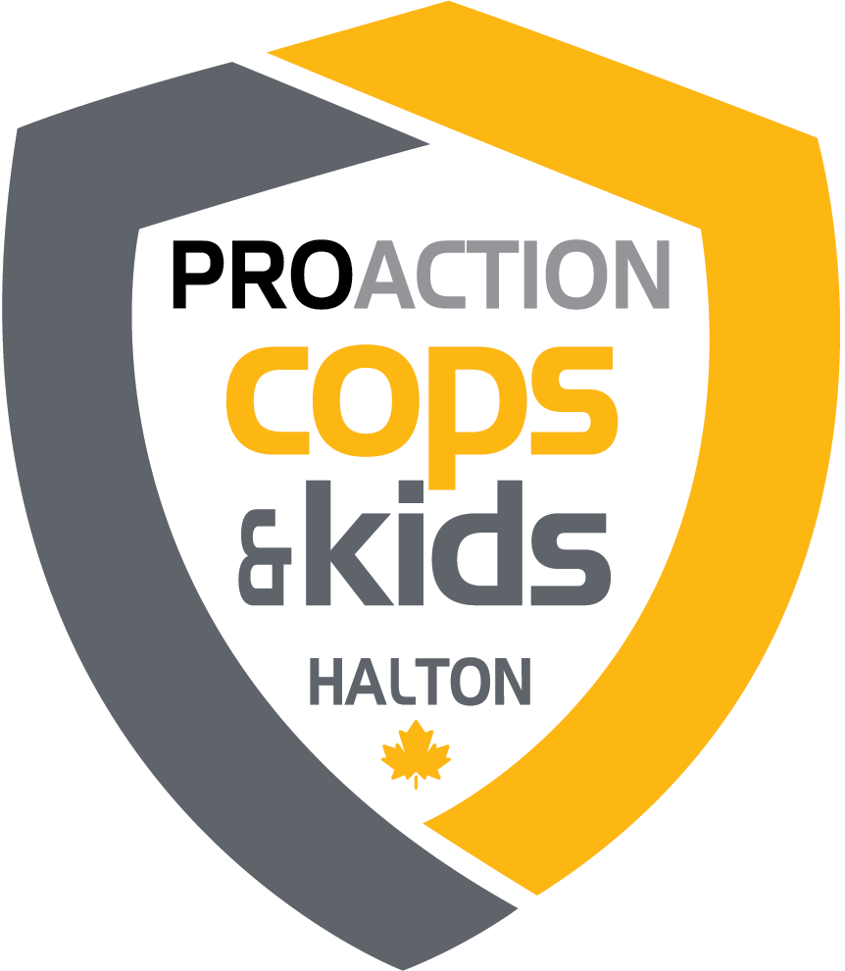

NOMINATION FOR PROACTION YOUTH AWARD

To recognize the youth who demonstrated the highest level of personal growth
causing them to stand out as the young person who has benefited
the most from a police-youth program, which was funded by ProAction and took
place in 2022 in Halton Region.
(Both in-person & virtual program participants are eligible)

Eligibility: 1) Examples of personal accomplishments throughout the program;
2) Recommendation from a Police Officer who was involved in the
program

Nomination: Police officers are asked to email their recommendations to
nicole@copsandkids.ca no later than Friday January 13, 2023.
Recommendations for this award shall be reviewed by the Halton
Chapter Council in consultation with the Halton Police Liaison.

Presentation: This award shall be presented at the ProAction Cops & Kids
Annual General Meeting.
.

Submitting Officer:
(Rank, First Name, Last Name, Badge No.)

Division/Unit:

Date:

Candidate’s Name:

Candidate’s Age:

Name of ProAction funded-program and Division in which they were /
are involved:

For how long has the candidate participated in this program?
(Please provide dates where possible.)

What role(s) did the candidate play?

How has the candidate developed or improved their attitude or skills as a result of participating in the program?

What other factors do you think should be considered in identifying this candidate as the individual who has shown the highest level of personal growth?

Please email this nomination form along with any attachments you wish to include by Friday January 13, 2023 to:

Nicole Benoit – Administrative & Program Coordinator
nicole@copsandkids.ca

Thank You!

